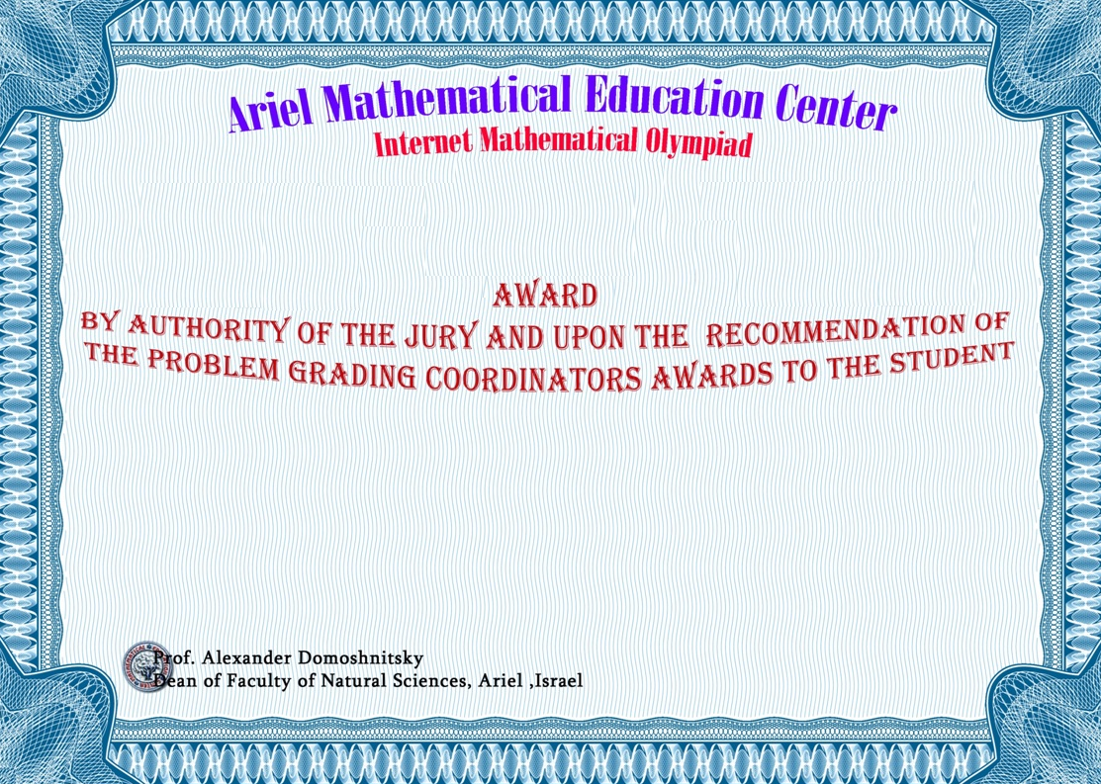

**2020**

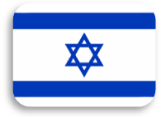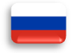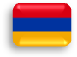

Stirbu Alexandru

Alexandru Ioan Cuza University of Iasi

**Gold Medals**

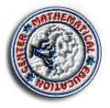

**Prof. Alexander Domoshnitsky**

**Chairman of Organizing Committee Ariel University, Israel**

